

Lab E5-VHDL Design Project

*EEE20001 Digital Electronics Design*

|  |  |  |  |  |
| --- | --- | --- | --- | --- |
| **1.** | **Student Name:** | **Sze XiJie** | **Student ID:** | **101222928** |
| **2.** | **Student Name:** | **Sarah Lau Li Tin** | **Student ID:** | **101220896** |
| **3.** | **Student Name:** | **Lee Kai Ze** | **Student ID:** | **101222041** |

|  |  |
| --- | --- |
| **Lab Supervisor Name:** | **Dr. Tay Fei Siang** |



May 12, 2021

Swinburne University of Technology Sarawak

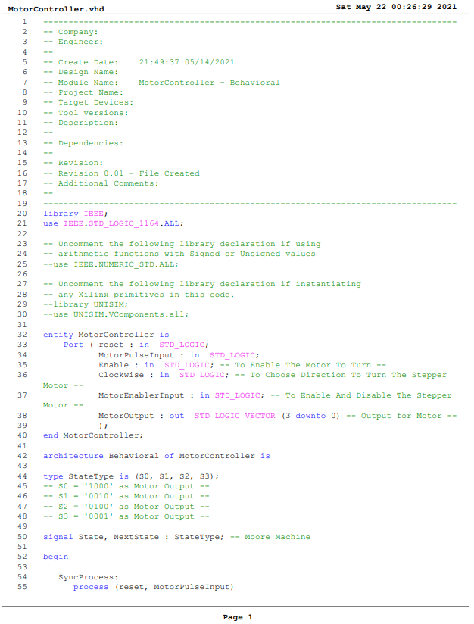

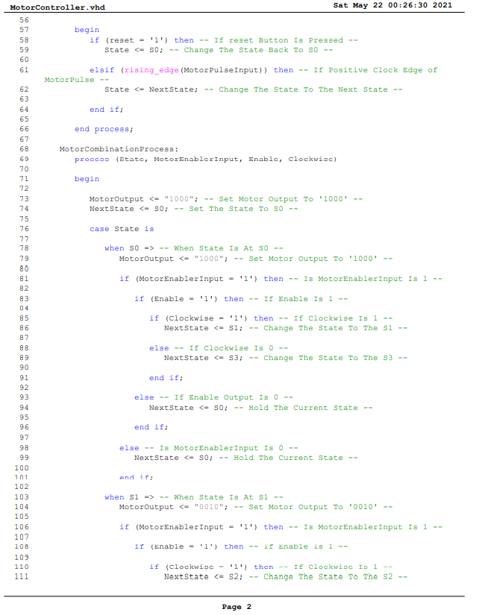

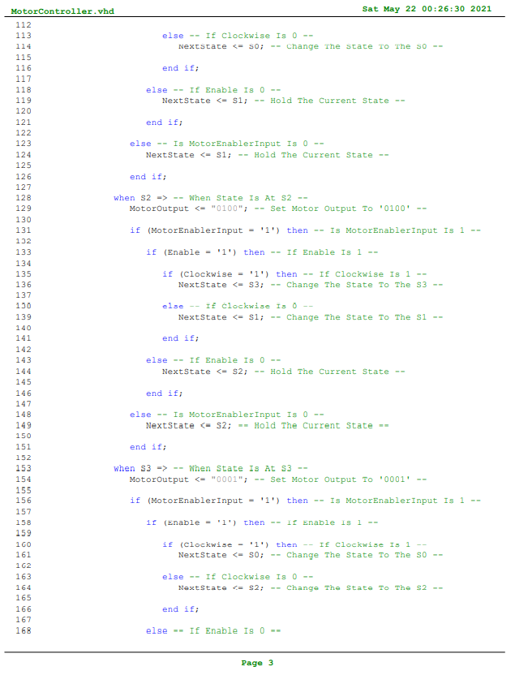

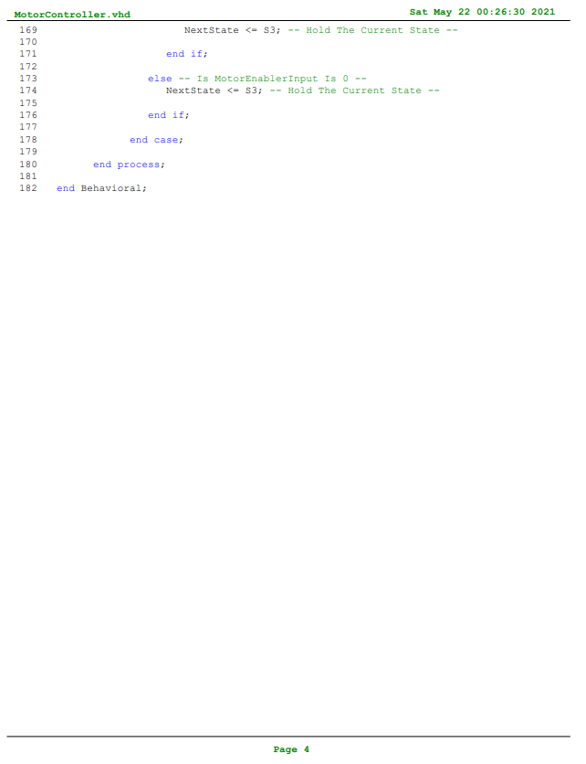

Figure : MotorController Module Code

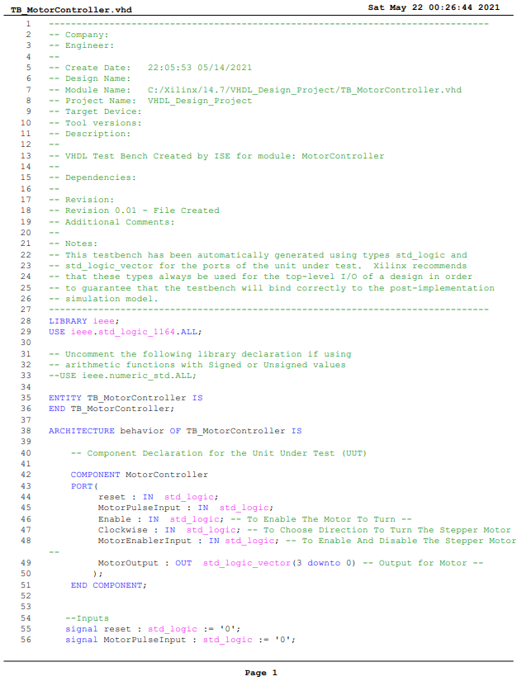

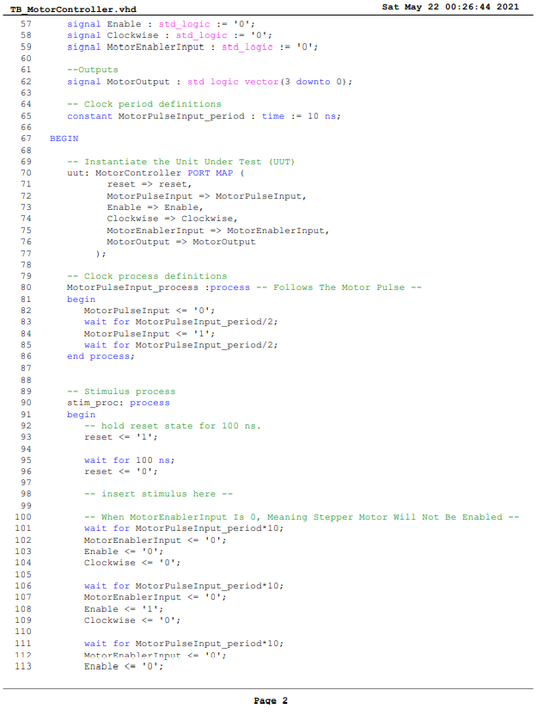

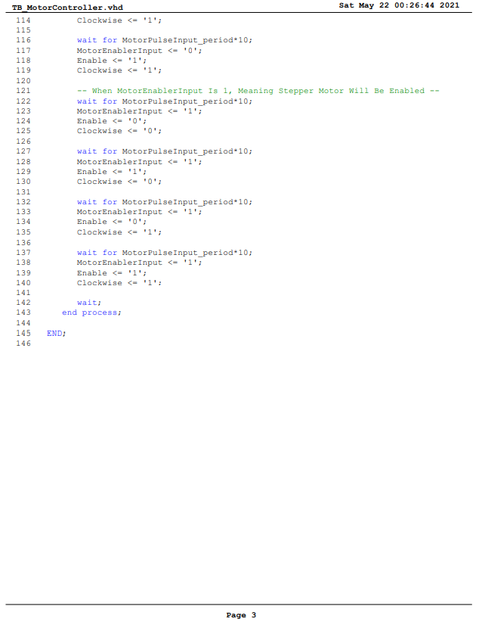

Figure : TB_MotorController TestBench Code

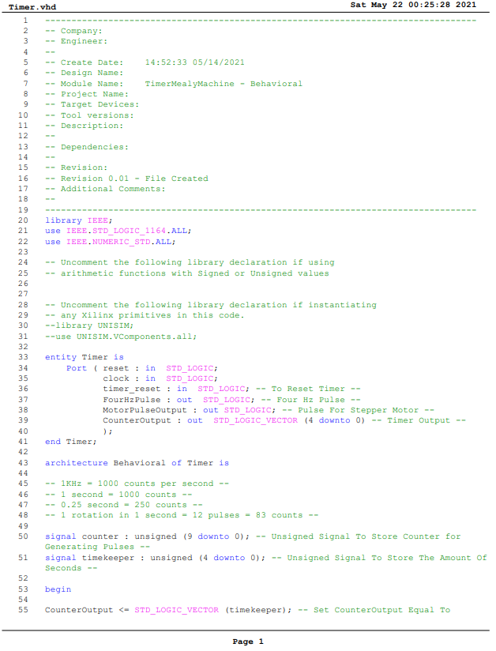

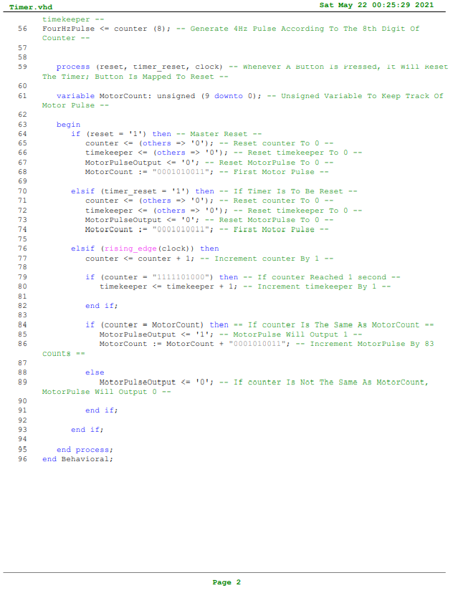

Figure : Timer Module Code

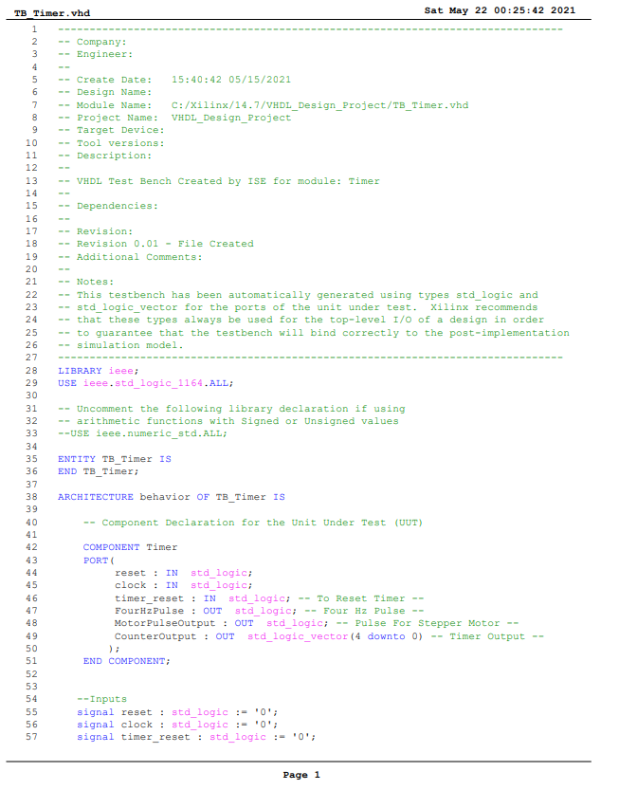

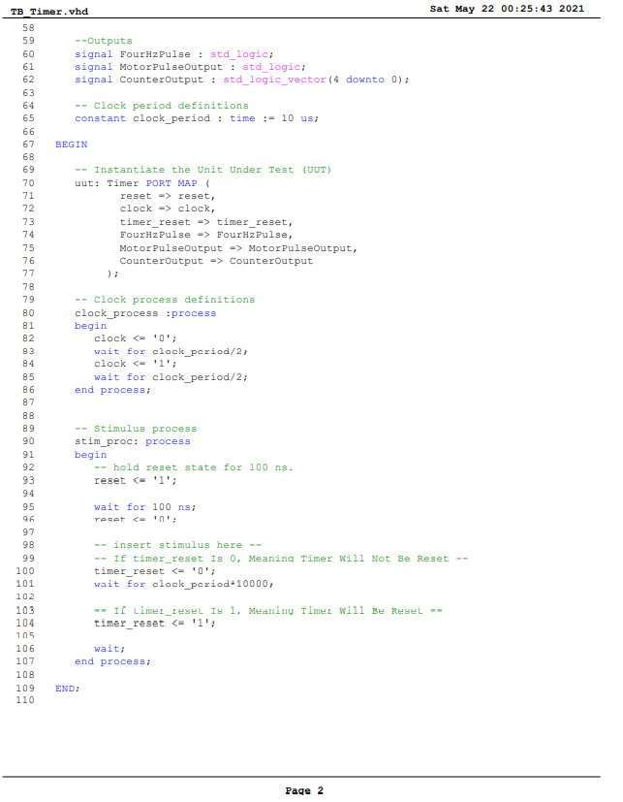

Figure : TB_Timer TestBench Code

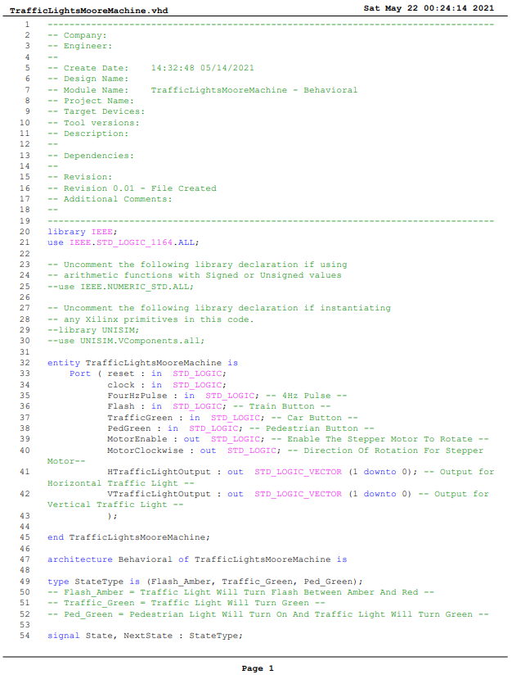

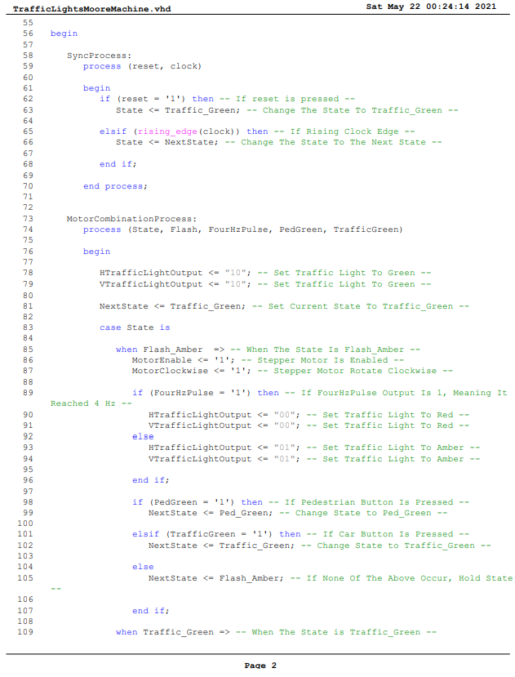

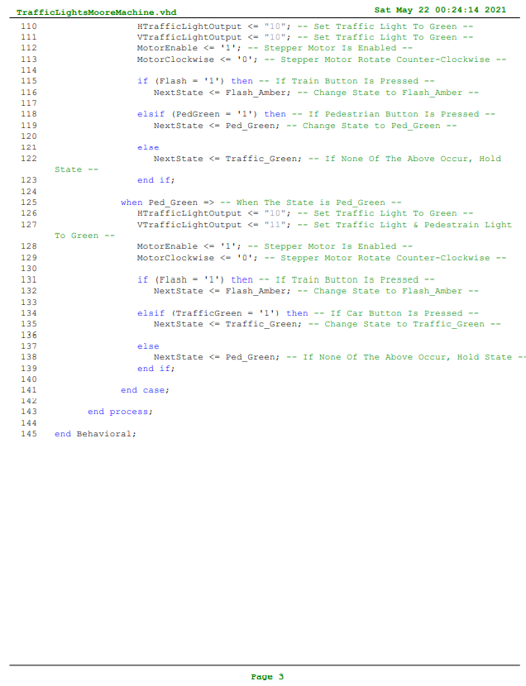

Figure : TrafficLightsMooreMachine Code

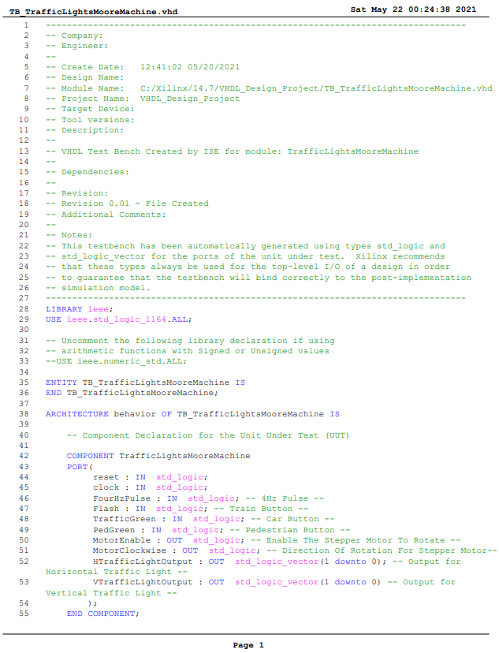

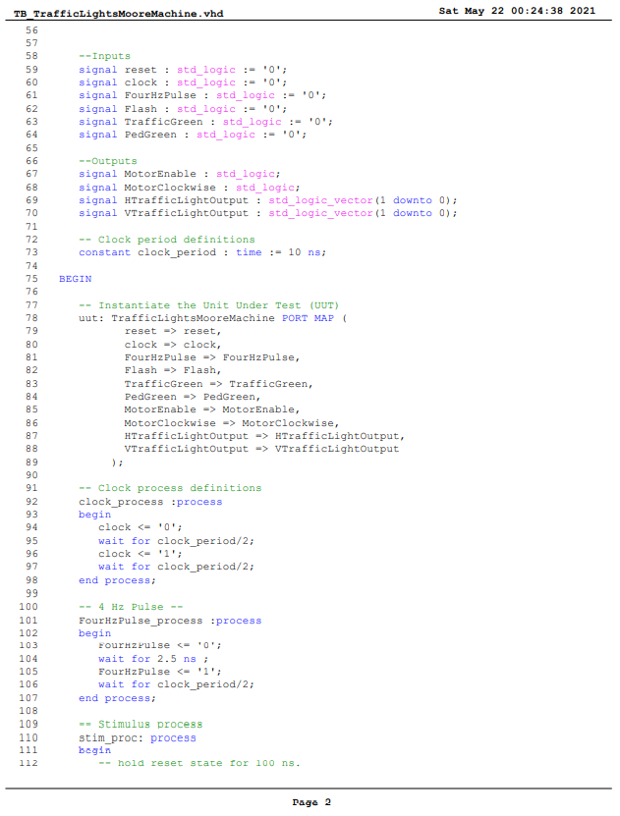

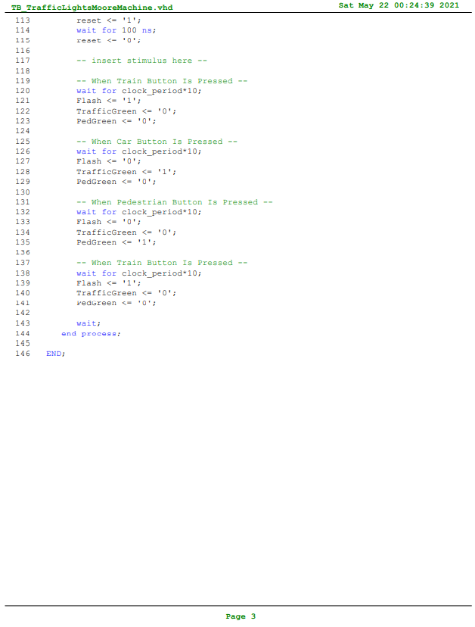

Figure : TB_TrafficLightsMooreMachine TestBench Code

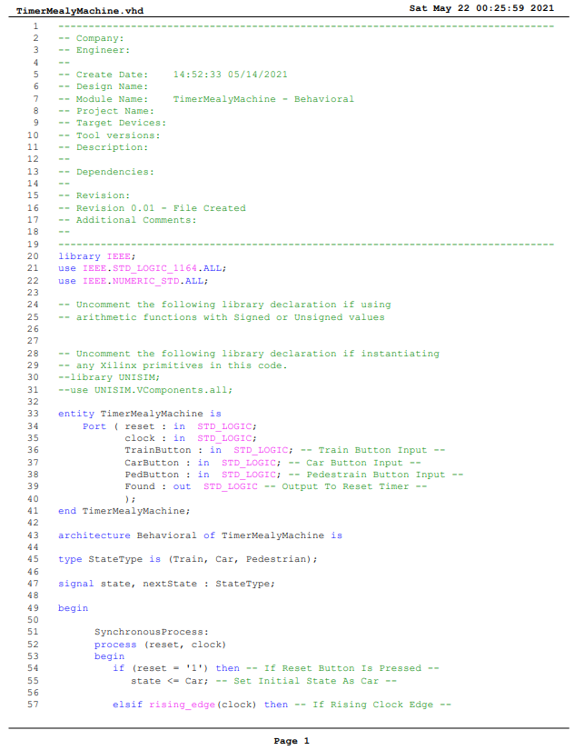

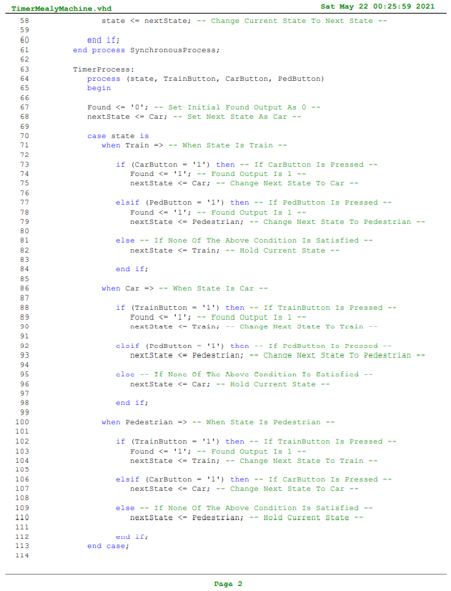

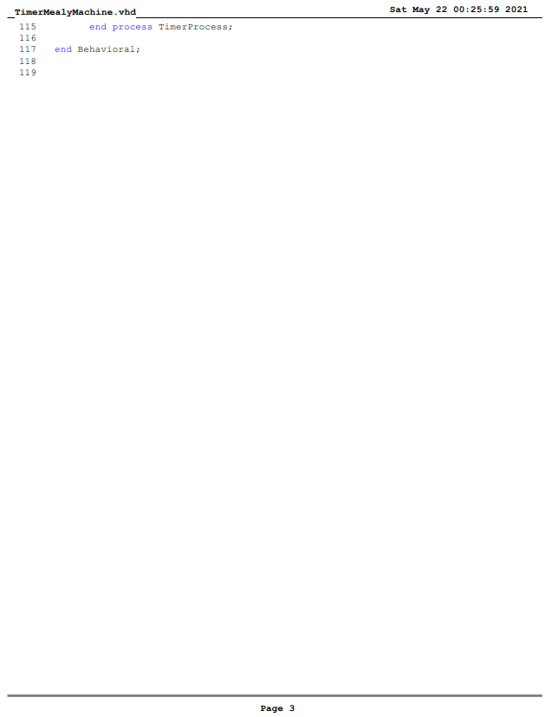

Figure : TimerMealyMachine Module Code

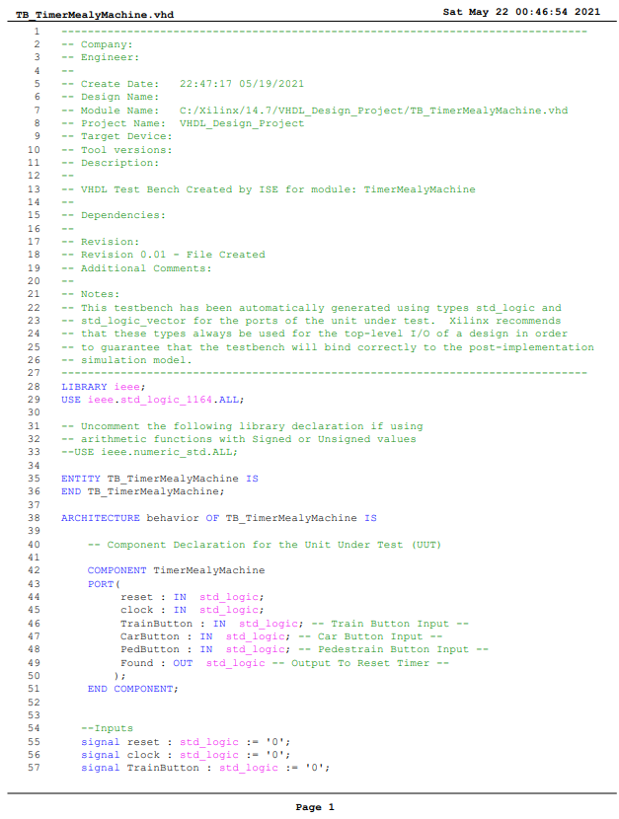

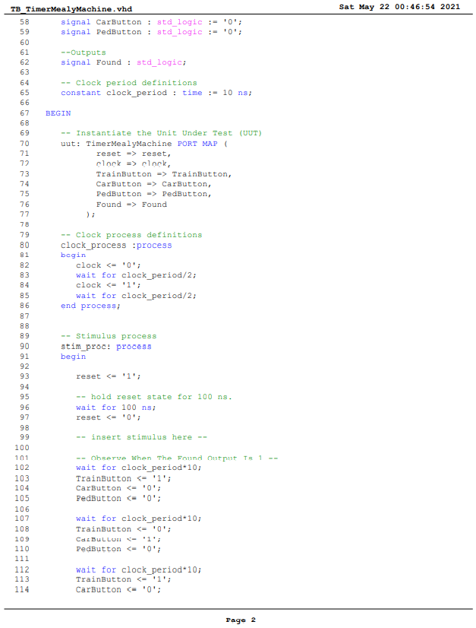

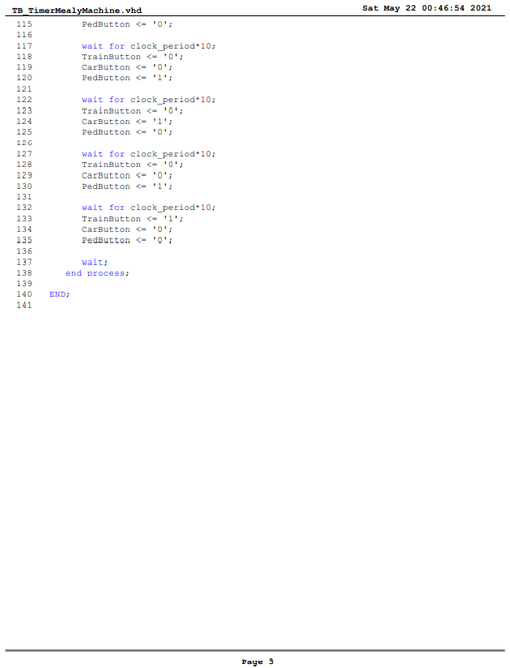

Figure : TB_TimerMealyMachine TestBench Code